PROJECT: IDID  Project: IDID (Innovatively Developing & Integrating Detroit) is a program that provides our youth and individuals, with skilled certification training, as well as other resources, for gainful employment to organizations seeking certified professionals to become an asset to their company. These resources consist of personal and professional development, job assistance and placement upon program completion, entrepreneurial endeavors, develop the acumen to restore the family/home structure, produce productive citizens, pillars In the community, and stimulate economic growth, with performance measures to track and mark the success of the individuals to show the success of the program and company.  Core Competencies:  A+ Program  Network+  Medical Assistant  CNA  Medical Billing/Coding  HealthCare IT certification training |  | Project R.E.S.T.O.R.E  Aids our communities in combatting the strongholds and challenges that plagues our communities through:  Reconstruction Education  Support Training  Organizing Responding  Employment |  | Our mission at Universal Quest Technologies is to breakdown the prominent challenges and fundamental strongholds that plague our youth by interpolating into our youth the acts of accountability and the roles of responsibility on being a pillar and leader in the home, which enhances the quality of life in our environment and bring constructive change within our communities.

Resource Center
Financial Literacy/Wealth Building
Housing Assistance
Medical Assistance
Testing Center
Training Facility
Staffing Agency
Daycare Facility
Resume` Building
Interpersonal Relations/Soft Skills
Practice Interview
 |  |  |  | 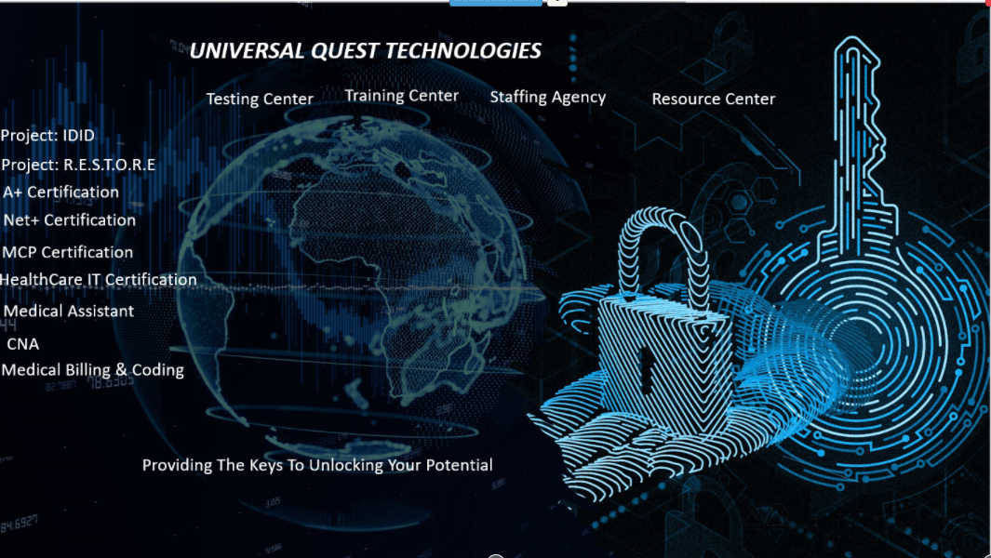
Universal Quest Technologies Events
Times and Locations TBD

Sporting Activity/Event: Family Events:
Basketball Tournament BBQ/Picnic
Baseball/Softball Tournament Bake Sale
Flag Football Tournament Cook-Off
Bowling Tournament Arts-N-Crafts
Horseshoe Tournament 50/50 Raffle/Reverse Raffle
Golf Tournament 5k Walk/Run
Pool/Billiards Tournament Student Teams Tournament
Card Game Tournament (Spades, Bid Whist, Poker) Blood Pressure and Diabetes check
Skills Clinic Concert/Talent Show
Bingo Tournament Carnival/Fair
Skills Clinic
Educational Clinic
Gala/Extravaganza Event: Pop up Restaurant
Formal Presentation Dinner Family Fun Day
w/Ballroom Exhibition Car Wash
w/Comedy Host Beer/Wine/Food Festival
w/Musical Performers
w/Auction (Date Night)
w/Hair-Fashion-Talent-Art Show
Networking Dinner/Mixer Back-2-School
Themed Dance Event/Ball Phone-a-Thon/
Organize a Play Bottle and Can Drive
Murder Mystery Dinner Party
Charity Theater Event

